Big Picture

Hibernate is basically a framework for persisting Java Objects in a database

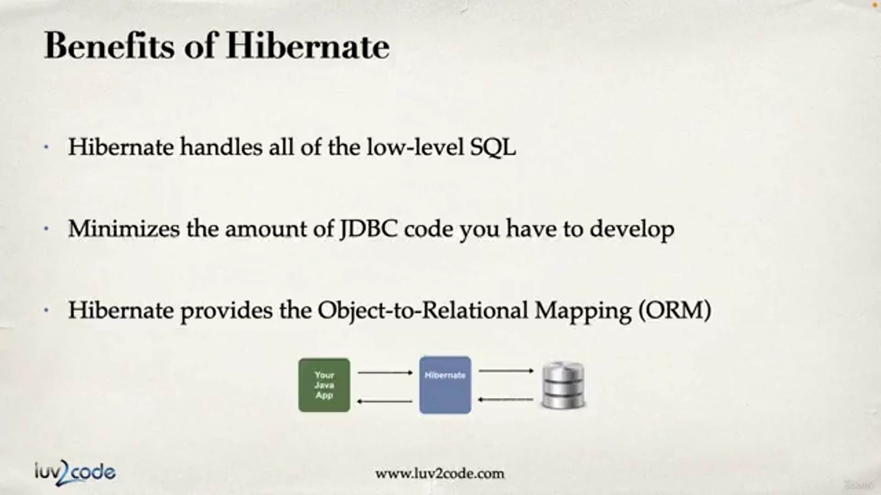

What is ORM?

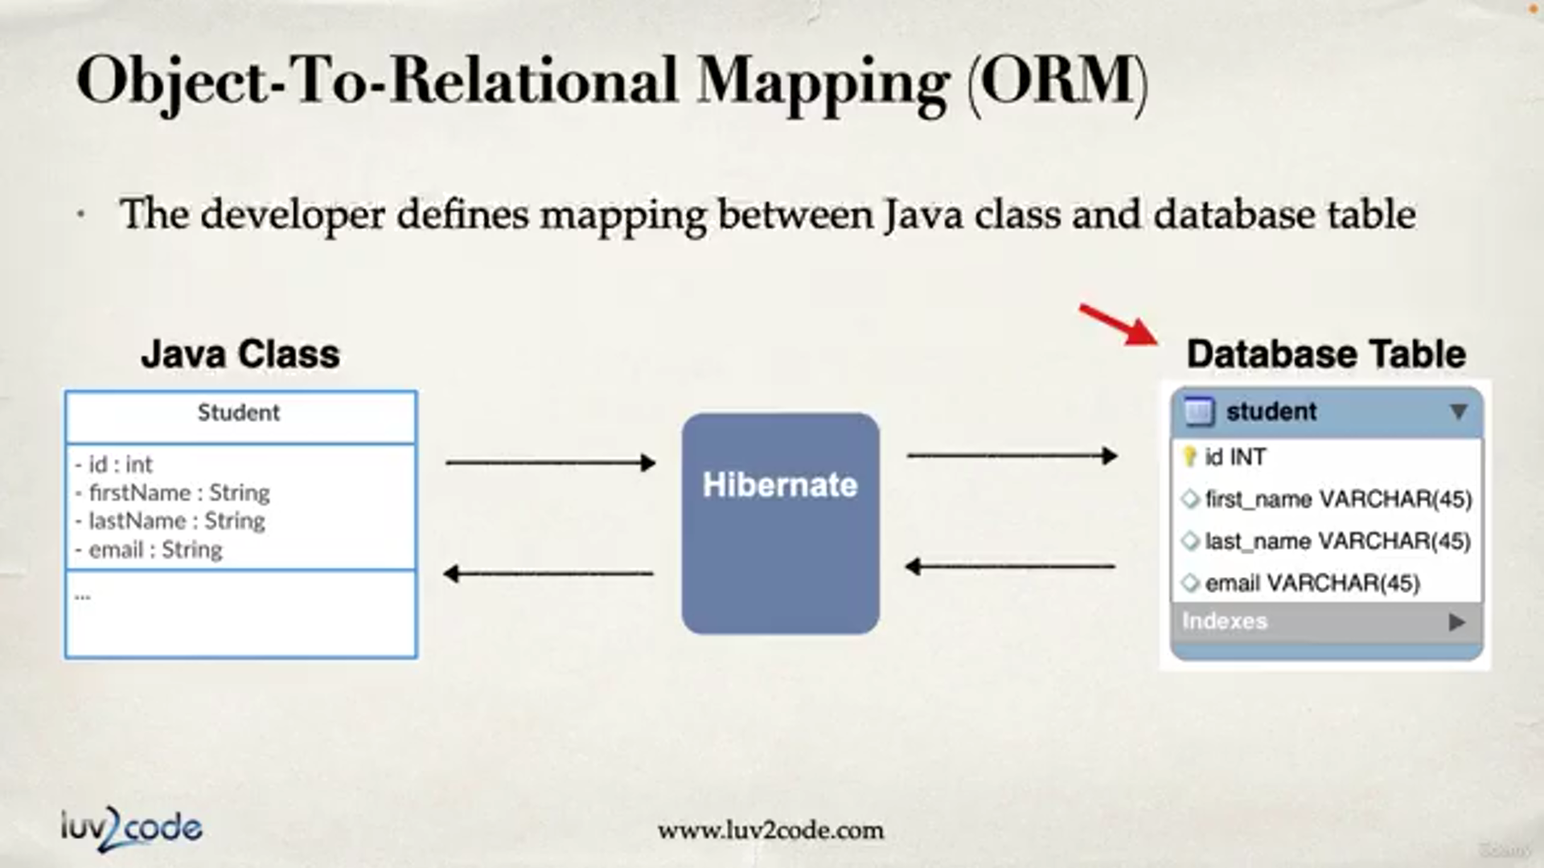

What is JPA ?

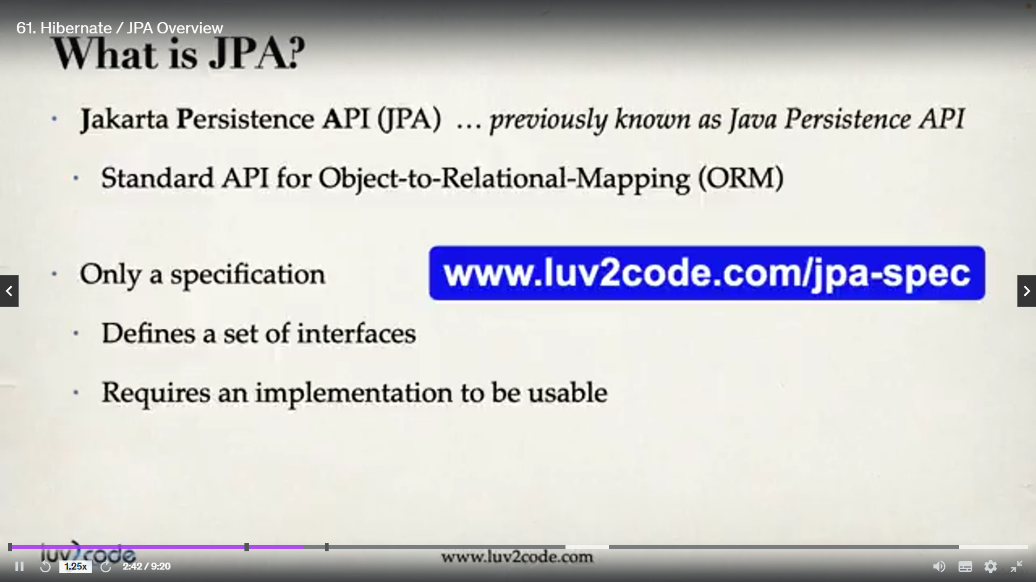

Note that JPA is only a set of interfaces specified by Java Developers for the sake of uniformity

It needs it implementation and can get it from either hibernate , ecllipseLink or other ORM vendors.

Basically it saves us from vendor locking and helps us write a portable code.

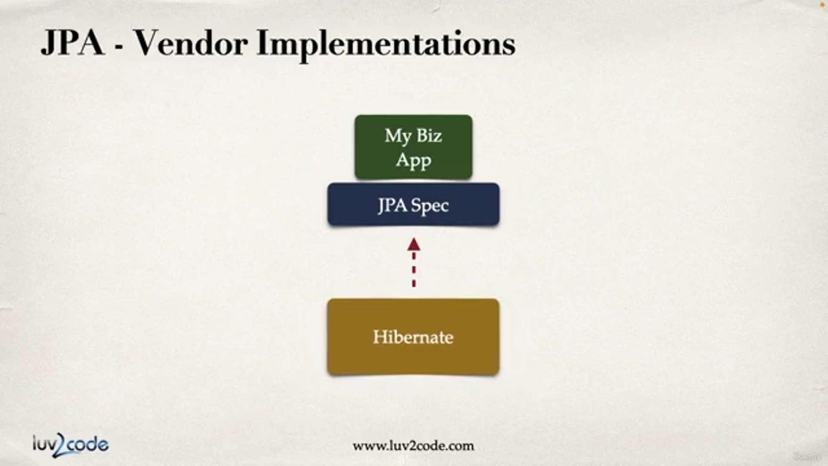

Can switch the implementation as per necessity without changing the application code.

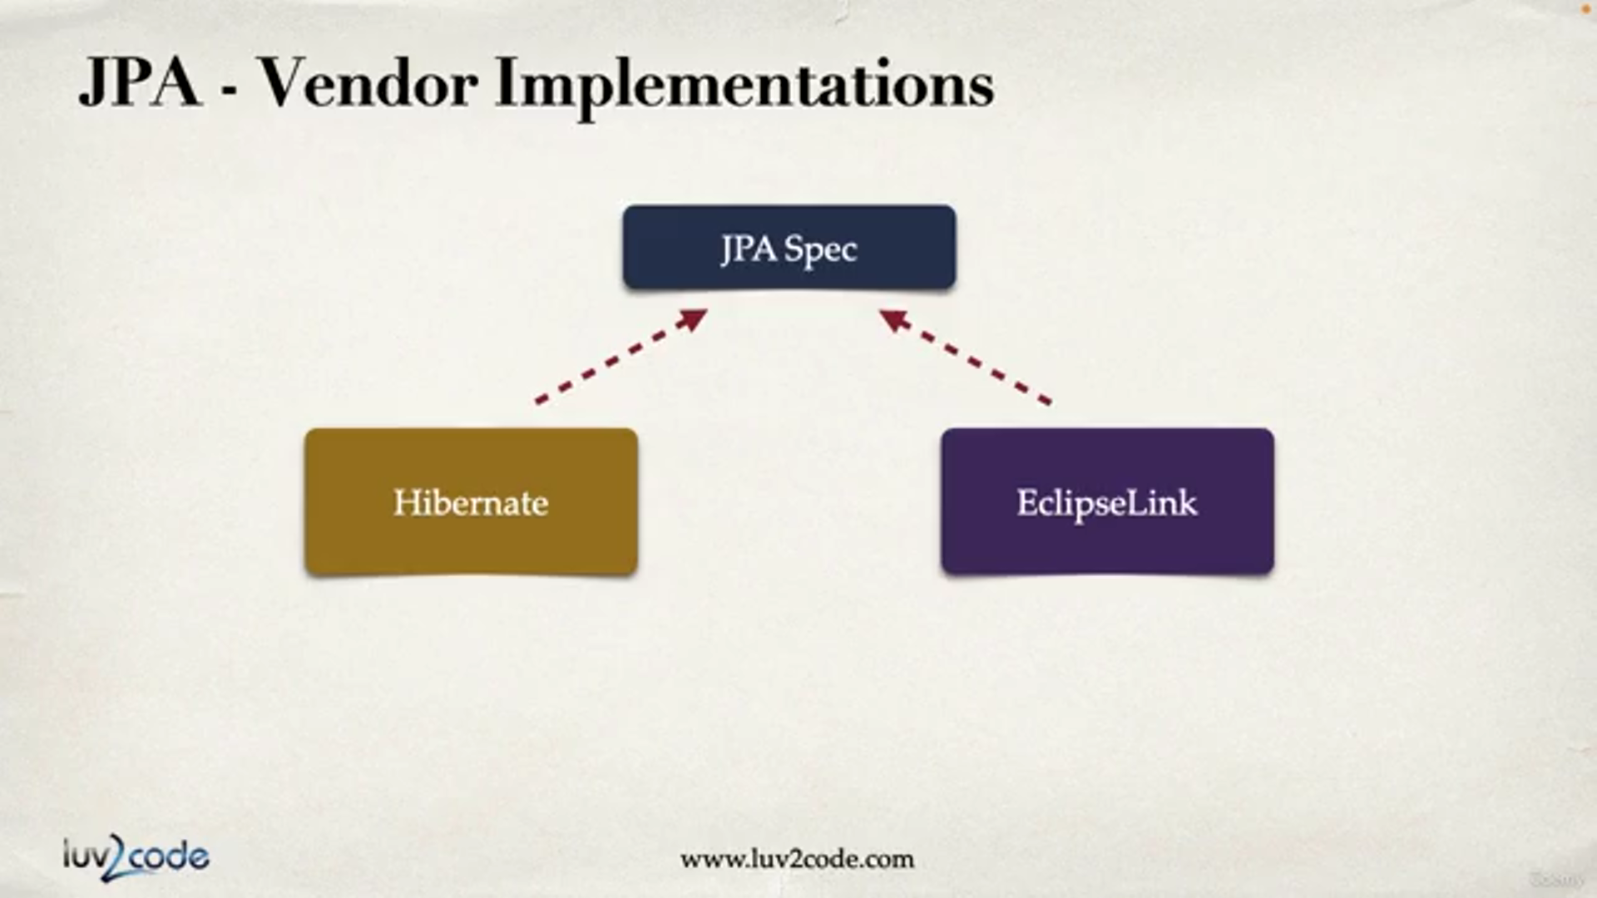

JPA Code

Saving Java Object using JPA.

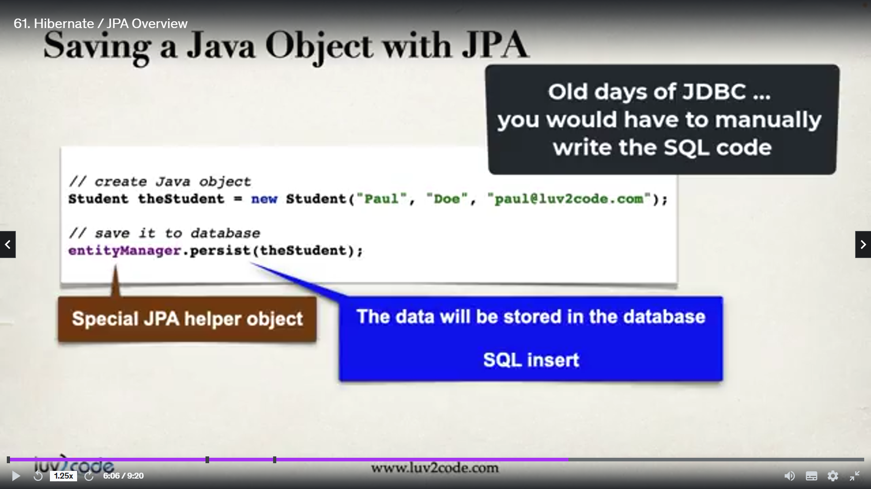

Retrieving single object from Database using primary Key

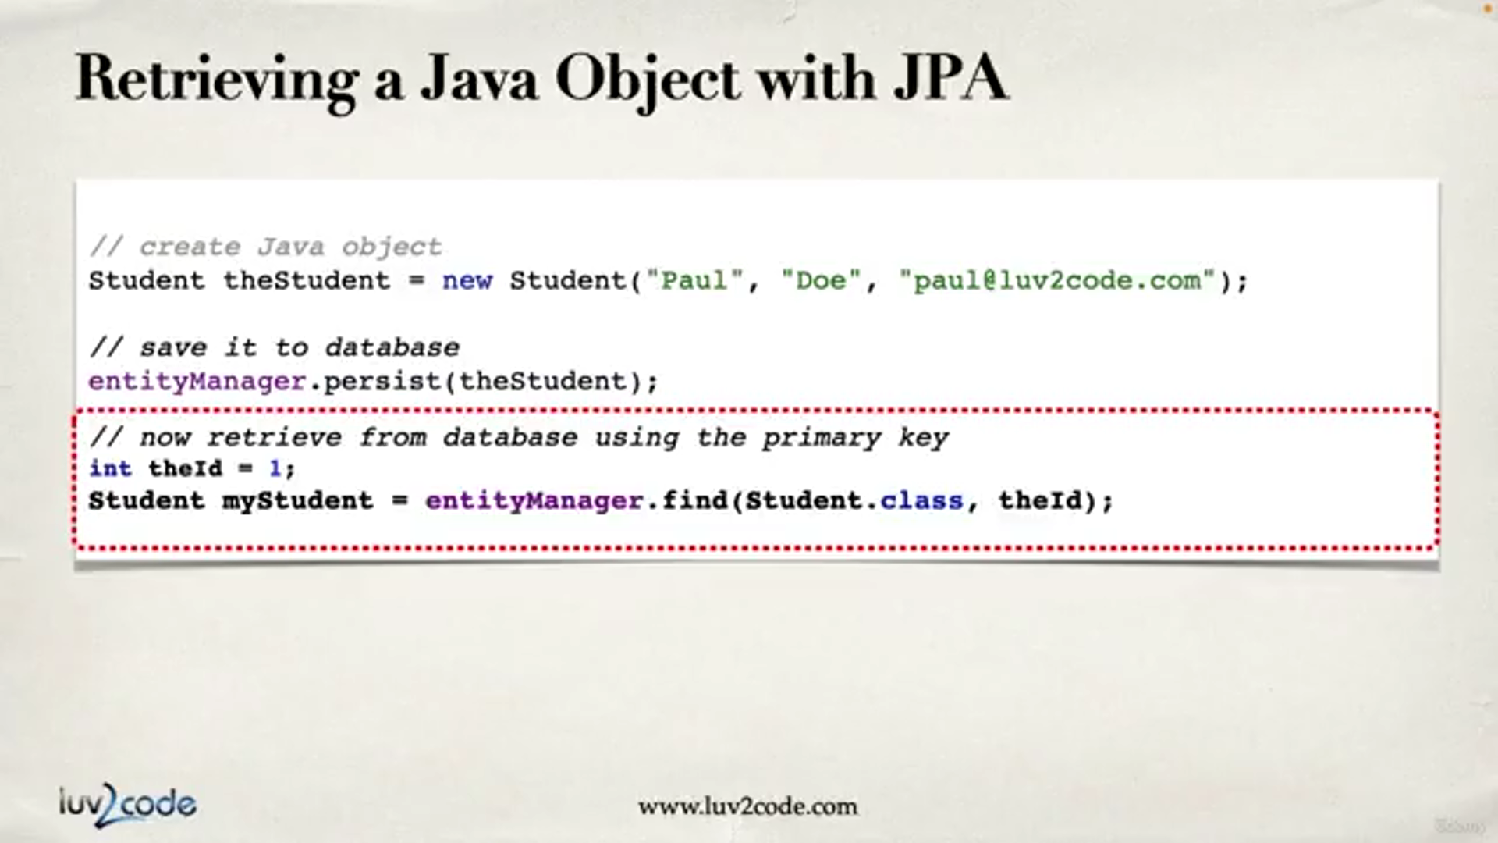

To retrieve multiple Objects using JPQL

